1) Changes To Search Fields For Claims Registration, Claims Payment and Claims Recovery
- To Include Vehicle No. as a Search Field
- Change Date Of Loss To Accident Date
- Remove Main Class Code and Sub Class Code Search Fields

2) Changes To New and Incomplete Claims Registration
Previous

- To Include Next and Previous Button in all the Tabs for New Claims Registrations and Incomplete Claims Registration Screen
- System must save all inputs when user clicks on the Next and Previous Buttons
- To Change Cancel Label to Reset

3) Changes To Claims Tab

- To Include Time Stamp on Created Date
- To Rename Deletion Of Record To Cancellation Of Record
- To Rename Record Deletion Date to Record Cancellation Date
- To Rename Record Deletion Reason to Record Cancellation Reason
- To Extend Wider for the Record Cancellation Reason’s Text Field (100 Characters)
- System is to take note that when User inputs a date on Record Deletion Date, User must also enter a Deletion Reason. When there are inputs and user clicks on save – System will prompt user with a Message “Are You Sure You Want To Cancel This Claim?” and have options to choose Yes or Cancel. If User clicks Yes, the System will cancel this Claim and update the Claim Status as Cancelled
- To Remove the Claim Amount/Payout Section
- To move the View Payment & Reserve History Button to Claims Adjustment & Claims Enquiry Screen
- To Default the Claim Status to “C”
- Initial Reserve created in this Tab must be recorded in the Reserve Tab
- Depot Workshop to be mapped to the Depot Master

[Varun 8-august-2014]
Regarding point number 8:
Query 1) Do we need to remove “payment and reserve history button“ from claim menu?

[Dexter 12-august-2014]
Response: The Button stays where it is… Users just do not want to see the button appearing when they are accessing the New Claims Registration and Incomplete Claims Registration Screen.

Query 2) Please provide details , In Claims Enquiry menu, how we will map this button functionality as this button gives response based on a specific claim number.

[Dexter 12-august-2014]
Response: Are we able to make this button clickable and viewable in the Claim Enquiry Menu since users are no longer able to edit any fields

Regarding point number 9:
[Varun 8-august-2014]
Query 1) claim status “ c “will make it ' Complete ' by default, do we need to do that or we make claim status by default as “ I “, which will make it “incomplete?

[Dexter 12-august-2014]
Response: C is for Current and I is for Insurer and F is for Finalized.

4) Changes To The Third Party Tab

- To Include Three New Dropdown Listings – Service Provider / Insurer / Individual
[Varun 8-august-2014]

* Queries : I) will these three value be added in “ other party type “ drop down list ?

[Dexter 12-august-2014]
Response: Yes. Each selection will bring up different screen fields.

- Fields for each Listing will be provided by CDGI
- When User selects Service Provider Type – change the Third Party Adjuster, Third Party Lawyer and Third Party Workshop to a Third Party Type with Listings Adjuster, Lawyer and Workshop
[Varun 8-august-2014]

* Queries: 1) Can we delete three text boxes “third party adjuster“, “third party Lawyer”, “third party workshop” and add one drop down list labeled as “Third party Type“.

[Dexter 12-august-2014]
Response: Yes. But take note this will only appear when User selects Service Provider under the “Other Party Type” Drop Down List.

- When User selects Individual – include a Yes / No Radio Box under the Third Party Individual Section for user to indicate “Is Claimant An Infant – Yes / No?” If User chooses Yes then an extra section will appear for Users to input information about Infant’s Parent details
[Varun 8-august-2014]

* Queries : 1) If claimant an infant no : then what text will come?
2) Please share what information we need to gather for Infant's parents details . And also mention number of text boxes to capture this information

[Dexter 12-august-2014]
Response: If Infant is no. Then the basic layout for capturing Individual Details will remain the same. Number of Text Boxes and Fields will be provided by CDGI. They have yet to respond back on this.

5) Changes To The Accident Tab
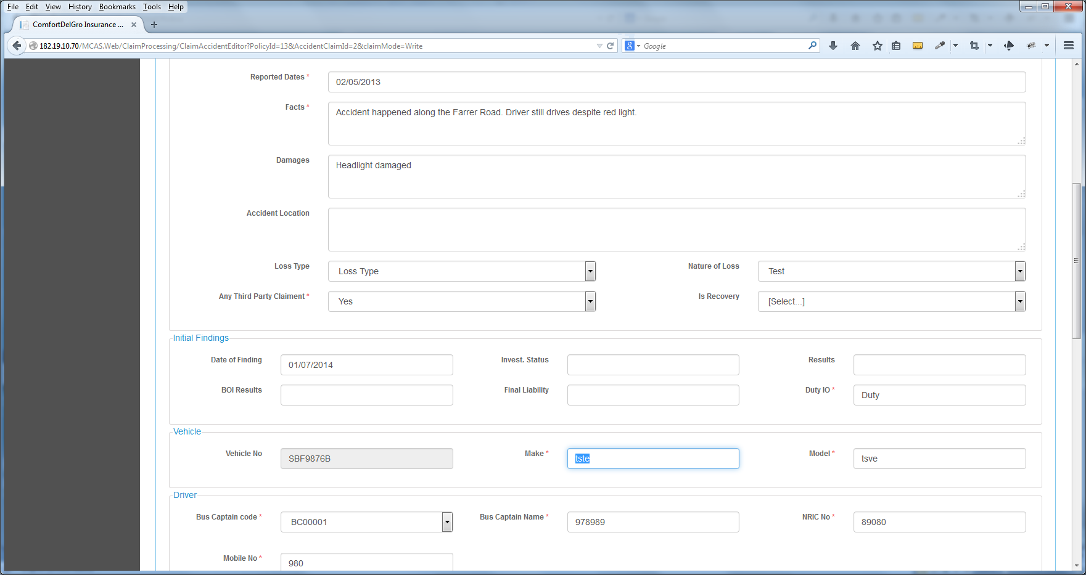
- Change the Is Recovery Label to Recoverable
- Vehicle Make and Vehicle Model are to match Vehicle No.
[Varun 8-august-2014]

Current process of vehicle.

1) On accident screen, we have smart search functionality on vehicle no. text box .
* For an example, if you type “v”, values resides in database starting with v will be displayed and user can search and select the record
* once that value selected and inserted in the text field , vehicle make and vehicle model will come automatically .
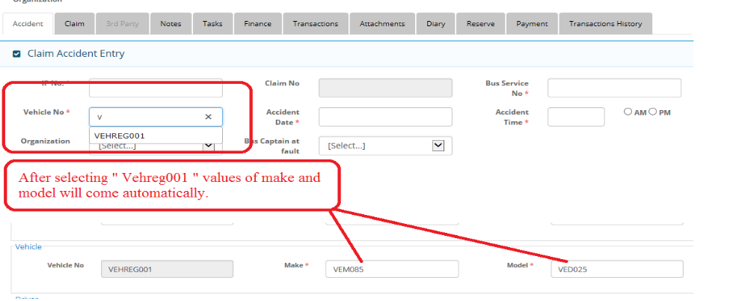
Query 1) : Vehicle make and Vehicle mode are editable and overitable by user . Do we keep this functionality ?
[Dexter 12-august-2014]
Response: Yes. Kindly ignore this request.

6) Changes To The System Admin Tab

- To include a Master Table and Tab for LOU Rate
[Varun 8-august-2014]

Query 1) Please provide screen layout and data elements to create new master screen

Query 2 ) Please provide details of LOU rate ( what is LOU rate , where it will be used ).

[Dexter 12-august-2014]
Response: LOU Rate is Loss of Use Rate. The values are currently 250 and 350. This will work with LOU Days and the output is 250 / 350 * Number of LOU Days. These fields will appear in the Finance Tab and CDGI will get back to us on where to place these two fields and the output fields.

Query 3 ) Kindly mention when it will be provided to us .

[Dexter 12-august-2014]
Response: We are still waiting for CDGI to get back.

- LOU Rate has only two values 250 & 350. Allow Users to add more values and to edit current Values.
- To include a Master Table and Tab for Hospitals
- Hospital Fields to be provided by CDGI
[Varun 8-august-2014]

Query 1) Please provide screen layout and data elements to create new master screen for hospitals/Clinic.

[Dexter 12-august-2014]
Response: We are still waiting for CDGI to get back.

7) Add New Unreported Claims Section
- Add a new Section – Unreported Claims Registration under Claims Registration and below Incomplete Claims Registration
- Allow All Fields to be input
- To have the functions to close the Case as well as to convert the Claims to the New Claims Registration

[Varun 8-august-2014]

Query 1) Do we need to add one more menu “ Unreported claims registration “ under claim registration menu

[Dexter 12-august-2014]
Response: Yes.

Query 2) We need to discuss this menu in details to get all requirements related to this menu.

[Dexter 12-august-2014]
Response: Noted.

8) Changes To The Diary Tab
- To Remove The Email Body Column
- Change the Add New Parties Label to Add New Diary

9) Changes To The Payment Tab
- To Grayed out the Payment Tab for all Sections except Claims Payment Module
- To integrate Finance Tab to the Payment Tab
- Include a Finance Breakdown Button next to the Cancel Button
- When user clicks on it – the Finance Tab will appear
- System will map the Local Currency Value and Payment Tab to one of the sections in the Finance Tab and System will need to balance out (make sure that all the breakdowns = Local Currency)
- Finance Tab will be removed
[Varun 8-august-2014]

Query 1) We need to discuss functionality finance screen data elements in details.

Note : Currently payment screen is only working in “claim payment processing“ as per above mentioned and we will disable “payment screen“ from all other screen but first we need clear understanding of finance screen.

[Dexter 12-august-2014]
Response: Noted.

10) Changes To The Transaction Tab
- To change the Transaction Tab to Mandate
- To change all Transaction Label to Mandate
- CDGI will come back to us to implement a Process Flow whereby Authorized Users will come to this Tab to approve Mandate Entries
[Varun 8-august-2014]
*1) When we will get response from CDGI for this requirement?

[Dexter 12-august-2014]
Response: We are still waiting for CDGI to get back.

11) Changes To The Reserve Tab
- To include a New “Add New LOG” Button (beside Add New Reserve Button)
- Follow the New Reserve Layout
- Change the Claimant Label to Hospital
- The Text Field will pull the results from the Hospital Master Table as User searches for it
- Previous, Reserve & Current Reserve will still follow the current layout and functionalities
- Include a new Type “LOG”
- All created LOG entries will also populate the View Reserve History Tables.

